Assessment Schedule – 2015

Physics: Demonstrate understanding of mechanical systems (91524)

Assessment Criteria
Achievement | Achievement with Merit | Achievement with Excellence
Demonstrate understanding requires writing statements that typically show an awareness of how simple facets of phenomena, concepts or principles relate to a described situation. For mathematical solutions, relevant concepts will be transparent, methods will be straightforward. | Demonstrate in-depth understanding requires writing statements that typically give reasons why phenomena, concepts or principles relate to given situations. For mathematical solutions, the information may not be directly useable or immediately obvious. | Demonstrate comprehensive understanding requires writing statements that typically give reasons why phenomena, concepts or principles relate to given situations. Statements will demonstrate understanding of connections between concepts.

Evidence
Q | Evidence | Achievement | Achievement with Merit | Achievement with Excellence
ONE  (a) | The force is weight / the force of gravity / gravitational force acting towards the centre of the Earth | - Gravitational / weight / gravity force acting towards the (centre of the) Earth.  (Accept radial or towards the earth)
(b) | 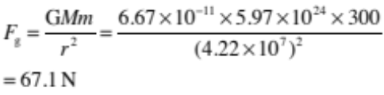 | - F_{g} = 67.1 N
(c) | Gravitational force must be equal to the centripetal force required at that radius so F_{g} = F_{c}  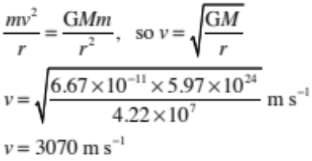  OR  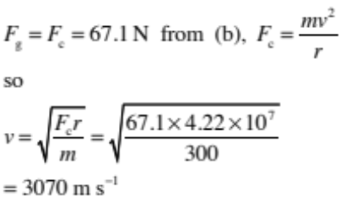  OR  The satellite is in geostationary orbit, so must take 24 hours (86 400 s) to complete one orbit  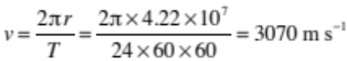 | - The gravitational force provides a centripetal force so F_{c} = F_{g}  (or use of 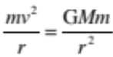)  OR  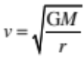  OR  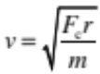  OR  The satellite is in geostationary orbit so must take 24 hours (86400 s) to complete one orbit  (or use of 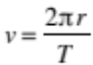) | - Use of 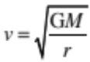 to prove  v = 3070 m s^{–1}  OR  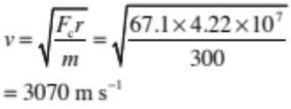  (allow M for follow on error carried forward for F_{c} from (b) )  OR  Use of to prove  v = 3070 m s^{–1}
(d) | 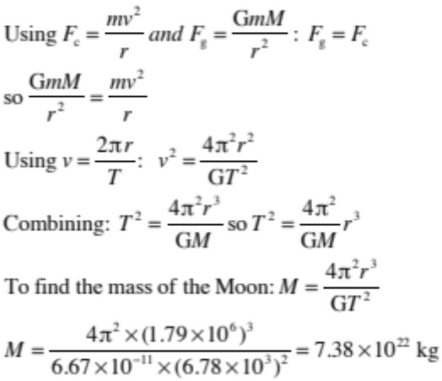 | - Uses F_{g}, F_{c} and to attempt to prove T ² ∝ r³. | - Uses F_{g}, F_{c} and to prove T ² ∝ r³. | - Uses F_{g}, F_{c} and to prove T ² ∝ r³.  AND  Calculates the mass of the moon, correctly, as being 7.38 × 10²² kg

Not Achieved |  |  | Achievement |  | Achievement with Merit |  | Achievement with Excellence
NØ | N1 | N2 | A3 | A4 | M5 | M6 | E7 | E8
No response; no relevant evidence. | Very little Achievement evidence. | Some evidence at the Achievement level, but most is at the Not Achieved level. | A majority of the evidence is at the Achievement level. | Most evidence is at the Achievement level. | Some evidence is at the Merit level. | A majority of the evidence is at the Merit level. | Evidence is provided for most tasks. The evidence at the Excellence level may have minor errors, or the evidence is weak. | Evidence is provided for most tasks and the evidence at the Excellence level is accurate.
No response; no relevant evidence. | 1A | 2A  OR  1M | 3A  OR  1A + 1M | 4A  OR  1A + E | 2A + 1M  OR  2M | 1A + 2M  OR  M + E | A + M + E-  OR  3A + E | A + M + E

Q | Evidence | Achievement | Achievement with Merit | Achievement with Excellence
TWO  (a) | The passenger and the bathroom scales are falling at the same rate, so there are no contact forces between them.  Accept support/normal forces/reaction force and free falling. | - Correct description.
(b)(i) | a = –1.54 × 10^{–6} y, y = A and ω² = 1.54 × 10^{–6}  a_{max} = –Aω² = 1.54 × 10^{–6} × 6.38 × 10⁶ = 9.83 m s^{–2}  OR  Maximum acceleration at Earth’s surface is g = 9.81 m s^{–2}. | - Use of suitable equation e.g.  v = –Aω² sinωt  OR  - Maximum acceleration at Earth’s surface is g. | - a = –Aω² = 1.54 × 10^{–6} × 6.38 × 10⁶ = 9.83 m s^{–2}  OR  - Maximum acceleration at Earth’s surface is g = 9.81 m s^{–2}
(b)(ii) | 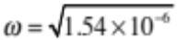rads⁻¹  V_{max} = A × ω = 6.38 × 10⁶ × 1.24 × 10^{–3} = 7910 m s^{–1}.  OR  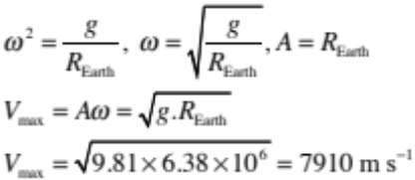 | - Use of suitable equation e.g.  v = –Aωcosωt  OR   | v = A × ω  = 6.38 × 10⁶ × 1.24 × 10^{–3}  = 7910 m s^{–1}  OR  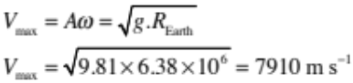
(c) | The acceleration or restoring force is in the opposite direction to the displacement (hence the negative sign) (y) / acts towards the equilibrium position.  The acceleration or restoring force is proportional to the displacement (y). | - Reference to a = –ω²y  OR  - F = –ky  OR  One of direction or proportionality | - Complete explanation of how the equation given shows that the elevator is undergoing simple harmonic motion.
(d) | 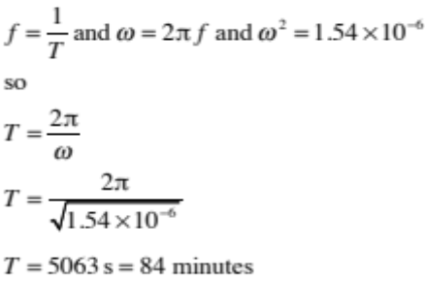  And journey will take half of one time period  so the time = 42 minutes.  OR  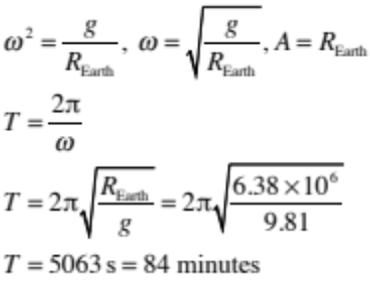  And journey will take half of one time period  so the time = 42 minutes.  OR  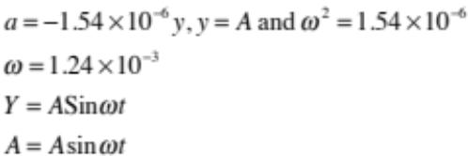  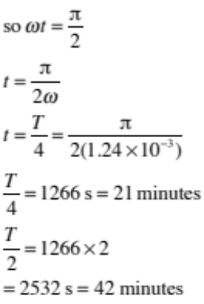 | - Combination of 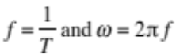  to get 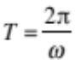  OR  OR  - Combination of 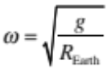 and  to get 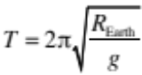  OR  - Incorrect answer but shows half the Time period.  OR  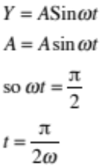 | - Combination of  to get AND  - to get 5063 s (84 minutes).  OR  - Combination of and  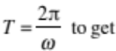  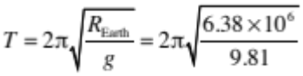  T = 5063 s = 84 minutes  OR  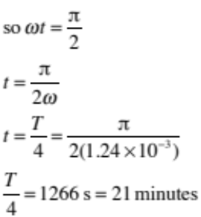 | - Combination of 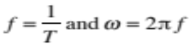  to get  - Use of and  ω² = 1.54 × 10^{–6} to get 5063 s (84 minutes)  - The journey time is 42 minutes (half the Time period).  OR  - Combination of and  T = 5063 s = 84 minutes  - The journey time is 42 minutes (half the Time period).  OR  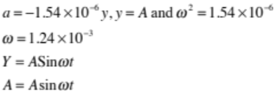

Not Achieved |  |  | Achievement |  | Achievement with Merit |  | Achievement with Excellence
NØ | N1 | N2 | A3 | A4 | M5 | M6 | E7 | E8
No response; no relevant evidence. | Very little Achievement evidence. | Some evidence at the Achievement level, but most is at the Not Achieved level. | A majority of the evidence is at the Achievement level. | Most evidence is at the Achievement level. | Some evidence is at the Merit level. | A majority of the evidence is at the Merit level. | Evidence is provided for most tasks. The evidence at the Excellence level may have minor errors, or the evidence is weak. | Evidence is provided for most tasks and the evidence at the Excellence level is accurate.
No response; no relevant evidence. | 1A | 2A  OR  1M | 3A  OR  1A + 1M | 4A  OR  2M  OR  2A + 1M | 1A + 2M  OR  1M + 1E | 3M  OR  1A + 1M + E | 2M + E  OR  3A + 1M + E | 1A + 2M + E

Q | Evidence | Achievement | Achievement with Merit | Achievement with Excellence
THREE  (a) | The centre of mass accelerates towards the ground as a single force (weight) acts upon it.  Linear momentum increases due to the external force (weight), causing an increase in vertical velocity. | - Centre of mass accelerates downwards.  OR  Linear momentum increases because the vertical velocity is increasing.  (Accept velocity is increasing.) | - Centre of mass accelerates downwards.  AND  - Linear momentum increases due to external force (weight) causing an increase in vertical velocity.  (Accept Momentum increases because velocity increases and the net (external) force is not zero.)
(b) | 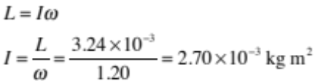 | - I = 2.70 × 10^{–3} kg m²
(c) | When the cat is in the air, no net external torque acts on it about its centre of mass, so the angular momentum about the cat’s centre of mass cannot change. Since the front half of the cat has increased angular momentum, the rear of the cat must increase angular momentum by the same amount but in the opposite direction in order to maintain a total angular momentum of zero. | - No external torques act.  OR  L_{rear} = –L_{front} | - No external torques act so total angular momentum must be conserved so rear half of cat must rotate but in the opposite direction.
(d) | L_{rear} + L_{front} = 0 so L_{rear} = –L_{front} = 3.24 × 10^{–3}  If the falling cat pulls in its front legs, the cat can decrease its rotational inertia / moment of inertia by changing its mass distribution.  If the falling cat stretches out its back legs, the cat can increase its rotational inertia / moment of inertia by changing its mass distribution.  By changing its rotational inertia / moment of inertia, the cat can change the speed at which it rotates. Since the angular momentum of each half of its body is a constant.  The cat rotates more quicky at the front of its body than at the back.  L_{rear} = –L_{front}  I_{rear} ω_{rear} = I_{front} ω_{front}  Since I ∝ mr²,  I ∝ r²  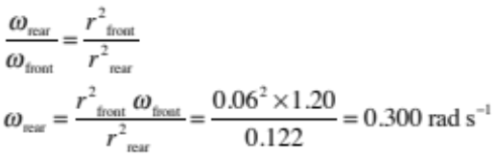 | - L_{rear} = 3.24 × 10^{–3} kg m² s^{–1}  OR  - The cat can change its mass distribution  OR  - Explains that the cat can change the rotational inertia of the front and back parts of its body independently  Accept inertia in place of rotational inertia. | - Explains that the cat can change the rotational inertia of the front and back parts of its body independently.  - Tucking in the legs distributes more of the cat’s mass close to the axis of rotation OR Stretching out the legs distributes more of the cat’s mass further from the axis of rotation.  - Explains that the cat can change the speed at which different parts of its body rotate by changing the mass distribution.  Accept inertia in place of rotational inertia.  Radius smaller is acceptable for mass closer to the centre/axis.  For (M), the candidate needs to have any two of the above three. | - Explains that the cat can change the rotational inertia of the front and back parts of its body independently.  - Tucking in the legs distributes more of the cat’s mass close to the axis of rotation so ω is quicker OR vice versa (i.e. stretching out the legs distributes more of the cat’s mass further from the axis of rotation so ω is slower)  - Calculates ω_{rear} = 0. 300 rad s^{–1}  Accept inertia in place of rotational inertia.  Radius smaller is acceptable for mass closer to the centre/axis.  For Excellence points (E), the candidate needs to have all three bullet points.  For (E–), the candidate needs to have any two of the above three.

Not Achieved |  |  | Achievement |  | Achievement with Merit |  | Achievement with Excellence
NØ | N1 | N2 | A3 | A4 | M5 | M6 | E7 | E8
No response; no relevant evidence. | Very little Achievement evidence. | Some evidence at the Achievement level, but most is at the Not Achieved level. | A majority of the evidence is at the Achievement level. | Most evidence is at the Achievement level. | Some evidence is at the Merit level. | A majority of the evidence is at the Merit level. | Evidence is provided for most tasks. The evidence at the Excellence level may have minor errors, or the evidence is weak. | Evidence is provided for most tasks and the evidence at the Excellence level is accurate.
No response; no relevant evidence. | A1 | 2A  OR  1M | 3A  OR  1A + 1M | 4A  OR  2A + 1M | 2M  OR  M + E | 2A + 2M  OR  1A + 1M + E | 2A + 1M + E- | 2M + E  OR  2A + 1M + E

Note: E- and E only applies to the E7 and E8 decision.

Cut Scores
Not Achieved | Achievement | Achievement with Merit | Achievement with Excellence
0 – 6 | 7 – 12 | 13 – 18 | 19 – 24

